Adam Evans

University of Central Lancashire

**Moses, Robert (1888- 1981)**

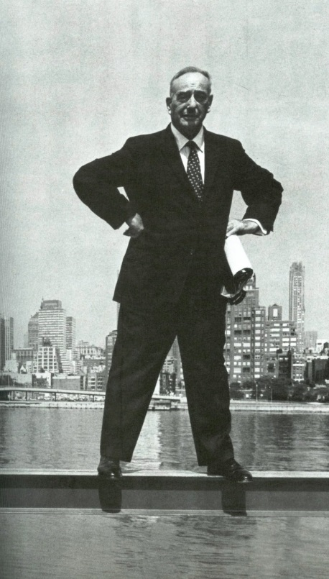

Robert Moses

<http://2.bp.blogspot.com/_Q5jG4MBzjac/RetXtbED1uI/AAAAAAAAANA/HFAwXYBCaz0/s1600-h/Moses.jpg>

Robert Moses was born in New Haven, Connecticut in 1888, relocating with his family to New York City in 1897. Moses studied at Yale University and subsequently Wadham College, Oxford, achieving his PhD in Political Science from Columbia University in 1914. His deep interest in politics was something that would shape his career, and in the following decades also shape most of New York City and state.

After graduating from his PhD, Moses turned his attention to reform politics in New York City; his first important work being his 1919 proposal to reform the New York State Government. Although these reforms were not sanctioned, his work had made an impact on Belle Moskowitz, an ally and advisor of statesman Al Smith. Smith became Governor of New York in 1922, and worked with Moses on a reform motion to consolidate the New York State Government. At this point Moses seized his opportunity and became a powerful presence in local government (despite never being elected) with proposals for his first wave of large scale public works projects. By utilizing Smith’s political position Moses influenced the approval of new legislation to enable these works to be delivered swiftly. These early works mainly consisted of beaches and parks under the newly established *State Council of Parks* and the *Long Island State Park* *Commission, LISPC* (1924). The projects executed in the first decade of the LISPC included the following parkways: *Southern State* (1925), *Wantagh State* (1927), *Northern State* (1931) and *Meadowbrook State* (1929), although the most notable of these early projects were *Heckscher State Park* (1929) which included social facilities for picnicking and boating, and *Jones Beach* (1929-30). Moses devotion to the automobile was evident even during this embryonic period, as these projects also included ample car parking facilities.

Although not a qualified planner, urban designer or architect, Robert Moses became acknowledged as New York City’s master builder (and later as New York’s ‘power broker’), a position he would hold for thirty-four years, from his appointment as the first city-wide commissioner of parks in 1934 by Mayor Fiorello La Guardia. During this time he would initiate an urban build programme comprising many public service works. Additional to his successful parks and beaches projects, Moses also proposed, directed and completed a tremendous number of swimming pools, schools, universities, public housing, retail complexes, office plazas, bridges and highways, the latter perhaps his best known work. *The* *Triborough Bridge* (opened 1936, renamed the Robert F. Kennedy Memorial Bridge in 2008), is a bold complex of three bridges spanning the Harlem River, Hell Gate (East River Strait) and Bronx Kill, and epitomises the tenacious attitude of Moses and his skill for attaining funding, as this was a project that had lain dormant since its inception in 1916 until he revived and updated the proposals and championed its construction.

Moses was an idealist, and had a clear, singular vision, which was to radically and formally modernise New York, favouring the International Style rather than the social values regarded in European Modernism. He was responsible for the United Nations decision to build the *UN Headquarters* in Manhattan rather than Philadelphia, and between 1946-53 Moses oversaw the development with Director of Planning Wallace Harrison and Max Abramovitz which included buildings be Le Corbusier and Oscar Niemeyer *(version 23/32,* developed with Bodiansky and Weissmann). Almost concurrently his program for urban renewal was launched; coinciding with the Mayor’s *Committee on Slum Clearance* (1949-1960), and the works designed under this program fully embraced his design agenda. These works also followed a series of design guidelines and building types, published by the *Committee on Slum Clearance.* Notable examples of public housing built under his program for urban renewal include Herman J. Jessor’s *Seward Park Housing,* 1958-60 and *Co-op City,* 1965-72 (borrowing much from Le Corbusier’s *Plan Voisin),* Maxon, Sells and Ficke’s *Delano Village,* 1952 and Eggers and Higgins’ *Washington Square Southeast,* 1953, all of which are tower blocks with typical modern hi-rise spatial planning solutions. The later *Lincoln Centre for The Performing Arts* continued to champion modernism; exemplifiedwithin buildings by Philip Johnson *(David H. Koch Theater,* 1964), Eero Saarinen *(Vivian Beaumont Theater,* 1965), Max Abramovitz *(Avery Fisher Hall,* 1962), Wallace K. Harrison *(Metropolitan Opera House,* 1966) and Skidmore, Owings and Merrill *(New York Public Library for the Performing Arts,* 1965) all executed under Moses’ direction.

Robert Moses’ attitude to modernism within his program for urban renewal was also linked solidly to issues of economics and timetable. His build program was accomplished at an incredible rate due to his ambition and the speed of modernist construction methods, completing more than 1,700 projects and appointing many well regarded modernist architects.

Robert Moses’ influence and the impact of his macro scale projects on New York City cannot be underestimated, and Moses remained a powerful master builder and city planner until his demise in 1968, when the Triborough Bridge and Tunnel Authority amalgamated with the MTA and Moses was ejected. The major criticism of the work of Robert Moses is that he held the automobile in such high regard that the presence of people became all but void in his vision. This coupled with his conceiving of all projects from aerial view led to a feeling that much of his work was over scaled and ignored the occupation of city space by pedestrians. Jane Jacobs, urban studies author, activist and nemesis of Robert Moses, campaigned strongly against his proposals for Greenwich Village arguing for the values of the small scale neighbourhood, eventually leading in 1962 to the ceasing of the proposed *Lower Manhattan Expressway (LOMEX)* which Moses conceived in 1940, making a case that his *Cross-Bronx Expressway* (1948-1972) was failing and displacing families and communities. This was a key turning point in Moses’ career. His approach to the problems of the city held small regard for preservation, conservation or indeed regeneration, and he refused to move forwards with newer urban thinking, dismissing community opposition to his work by stating: ''I raise my stein to the builder who can remove ghettos without removing people as I hail the chef who can make omelettes without breaking eggs.''

Despite Moses’ resulting reputation and heavy criticism from younger planners, his vision for the future influenced city planning and urban strategies in many US cities; and perhaps more importantly Moses championed new parklands, increasing the amount of parkland in New York State to over 2.5 million acres, and 658 playgrounds in the city alone.

**List of Important Works**

**Beaches**

1929-30 Jones Beach, New York

1938 Pelham Bay Park, New York

**City Parks**

1934-62 Central Park (additions to Central Park including Conservatory Garden, Loeb Boathouse and remodelling of Zoo. Central Park originally established 1859), New York City

1934-68 Randall’s and Wards Islands, New York

**Roads**

1934-37 West Side Improvement Project (including Henry Hudson Parkway), Bronx and Manhattan, New York City

1940-62 Lower Manhattan Expressway, New York City (unbuilt)

1950 Mid-Manhattan Expressway, New York City (unbuilt)

1948-63 Cross-Bronx Expressway, Bronx, New York City

**Bridges**

1933-36 Triborough Bridge, linking Queens, Wards Island, Manhattan, Randall’s Island, and the Bronx

1937 Henry Hudson Bridge, linking Manhattan to the Bronx

1937-39 Bronx-Whitstone Bridge, linking Queens to the Bronx

1956-61 Throgs Neck Bridge, linking the Bronx to Queens

1939-1950 Brooklyn-Battery Tunnel and Bridge, linking Brooklyn to lower Manhattan (bridge unbuilt)

**Housing and Urban Renewal**

1951-1959 Washington Square Village, Manhattan, architect: S.J. Kessler and Sons with Paul Lester Wiener

1952-1962 Delano Village, Manhattan, architect: Maxon, Sells and Ficke

1951 Williamsburg, Brooklyn, architect: Skidmore, Owings & Merrill

1959 Battery park Apartments, Manhattan, architect: Mies van der Rohe (unbuilt)

1965-72 Co-op City, the Bronx, architect: Herman J. Jessor

**References and further reading:**

Ballon, H. and Jackson, K.T. (eds), (2007), Robert Moses and the Modern City: The Transformation of New York, New York: W.W. Norton.

Caro, R., (1974), The Power Broker: Robert Moses and the Fall of New York, New York: Knopf.

Cranz, G., (1982), The Politics of Park Design: A History of Urban Parks in America, Cambridge, Mass: MIT Press.

Flint, A., (2011), Wrestling with Moses, New York: Random House.

Moses, R., (1914), The Civil Service of Great Britain, New York: Columbia University Press.

Moses, R., (1970) Public Works: A Dangerous Trade, New York: McGraw-Hill.

Plunz, R., (1990), A History of Housing in New York City: Dwelling Type and Social Change in the Metropolis, New York: Columbia University Press.

**Visual material:**

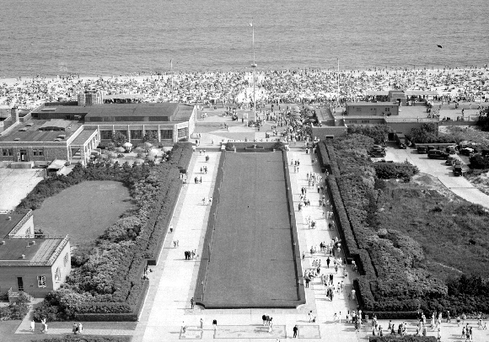

Jones Beach, New York, 1929-30.

Source: <http://www.osiny.org/images/content/pagebuilder/Jones_Beach_1937_NYS_Office_Parks_and_Rec.jpg>

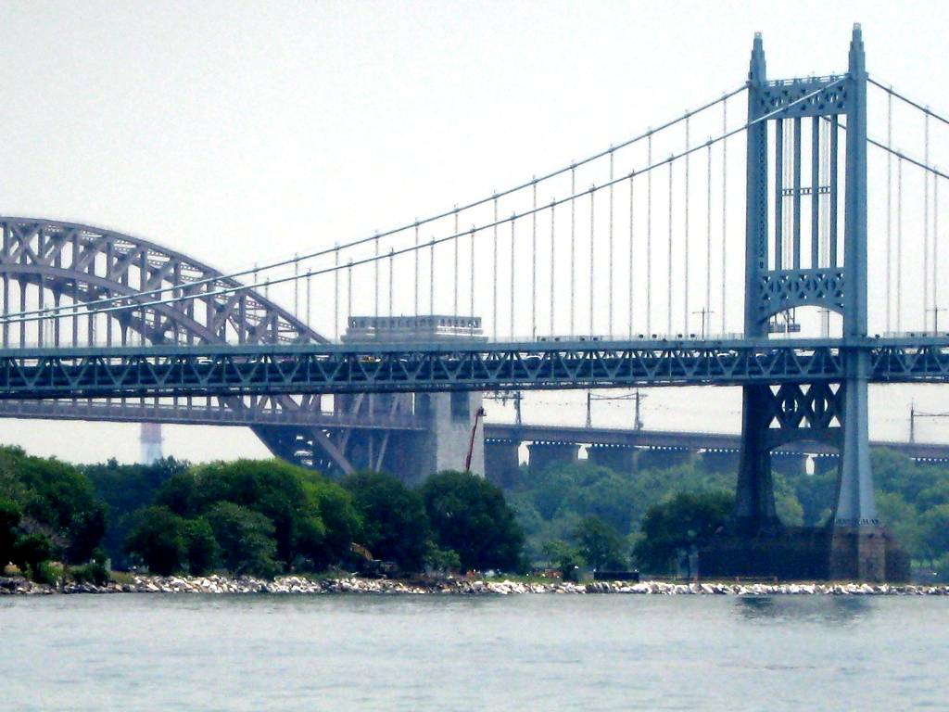

Triborough Bridge, New York City, 1933-36.

Source: <http://www.zingerbug.com/Backgrounds/background_images/triborough_bridge_in_new_york_city.jpg>

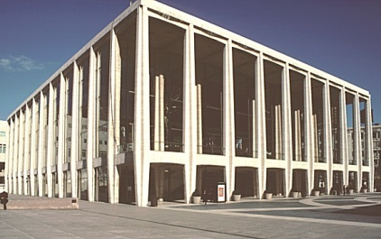

Avery Fisher Hall, Lincoln Centre for The Performing Arts, New York, 1962, architect: Max Abramovitz

Source: <https://www.bluffton.edu/~sullivanm/abram/angle.jpg>

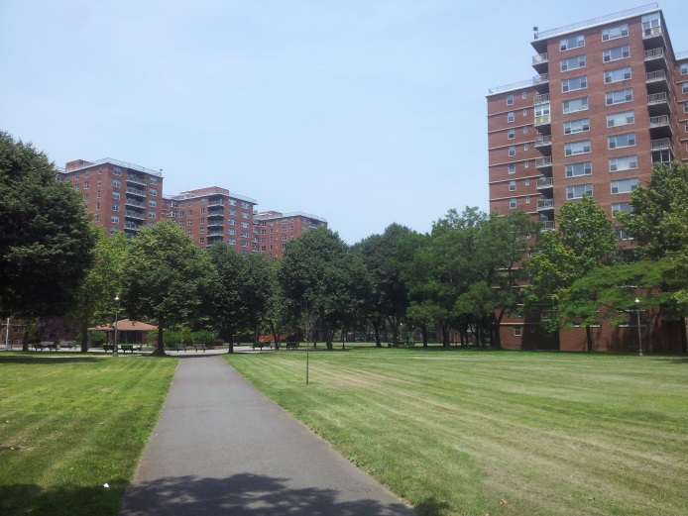

Rochdale Village, Queens, New York City, 1963, architect: Herman J. Jessor

Source: <http://glynrobbins.files.wordpress.com/2012/07/rochdale-village-5.jpg>

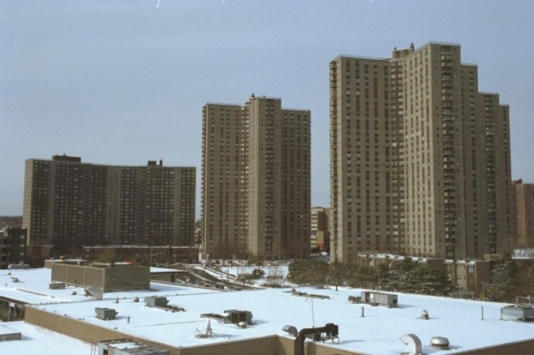

Co-op City, the Bronx, New York City, 1965-72, architect: Herman J. Jessor.

Source:[http://assets.nydailynews.com/polopoly_fs/1.1615051!/img/httpImage/image.jpg_gen/derivatives/article_1200/co-op-city.jpg](http://assets.nydailynews.com/polopoly_fs/1.1615051!/img/httpImage/image.jpg_gen/derivatives/article_1200/co-op-city.jpg%20)